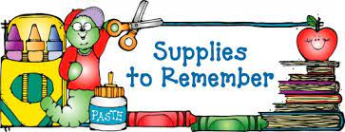

First Grade

*1 Book Bag

*1 Pencil Box

*2 packs of pencils

*2 boxes of crayons (24 count)

*1 box of colored pencils

*1 pair of scissors

* 4 glue sticks

*1 pair of over-the-ear headphones

*2 marble composition notebooks

*loose leaf wide-ruled paper

*3 folders with pockets and brads

**Wish List**

1 large bottle of hand sanitizer

2 boxes of tissue

1 box of clorox disinfectant wipes